Name: Madireddy Mahesh

Batch: March 1st 2022

Tutor: Raham Shaik

Project Name: Software Installation

* **Java Installation on Ubuntu:**

1. Created an Ec2 Instance with Ubuntu Image
2. Updated the Instance by using (apt-get update -y) command
3. Install JRE package by using (apt-get-default-jre -y) command
4. Install JDK package by using (apt-get-default-jdk -y) command
5. Check JAVA Version by using (java –version) command
6. Listed the JVM by using the (ls/usr/lib/jvm/) command
7. Installed the vim package by using the (apt install vim -y) command
8. written the script on the vim /etc/profile.d/jdk11.sh
9. echo $ JAVA_HOME
10. if above command not works reboot or restart the server
11. Echo $PATH

* **RUN A BASIC JAVA PROGRAM:**

1. **Vim demo.java**

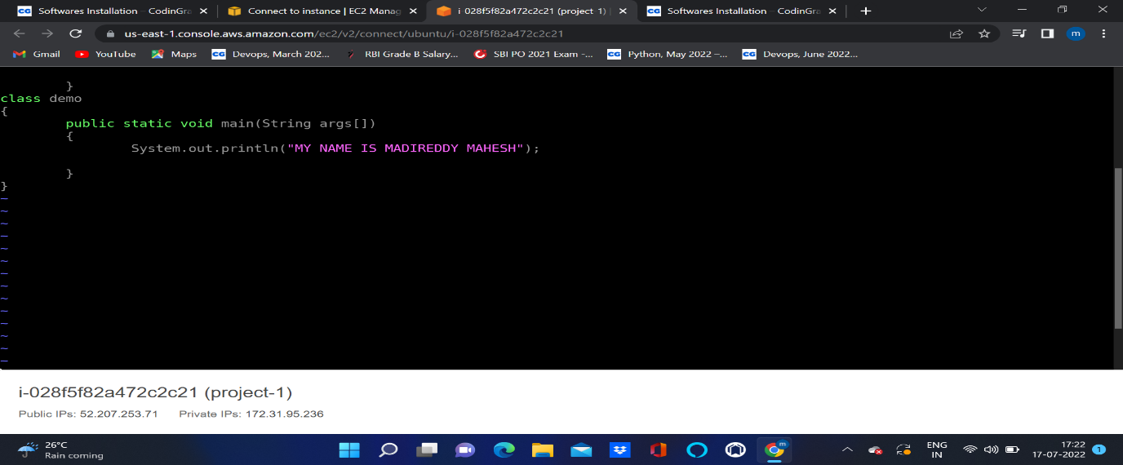

1. To Compile the program by using (javac demo.java) command
2. To Execute the program by using (java demo) command

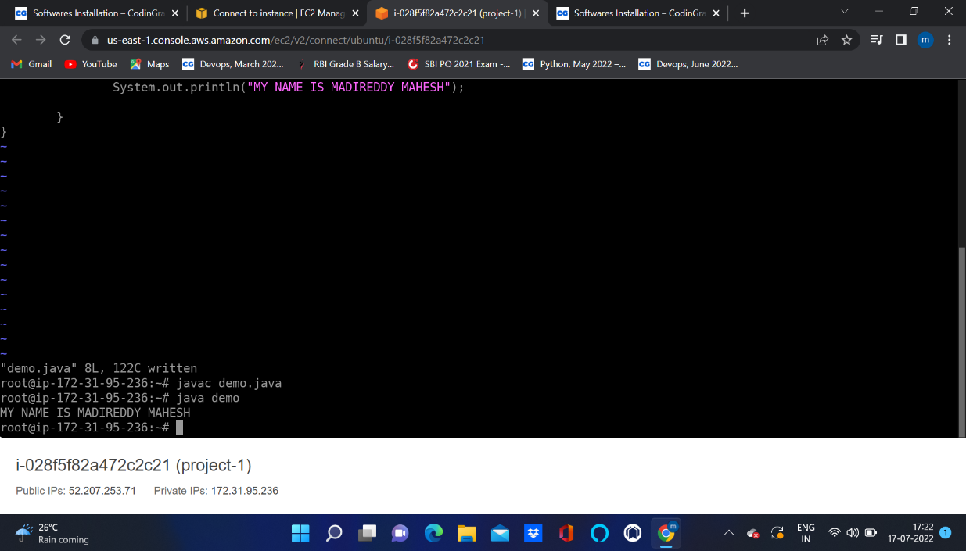

* **PYTHON INSTALLATION ON UBUNTU:**

1. **Update the server by using the command (sudo apt-get update -y)**
2. **Install python3 by using the command (apt-get install python3 -y)**
3. **Install python3.8 by using the command (apt-get install python3.8 -y)**
4. **This will take you to space where you can write your code**

* RUN A BASIC PYTHON PROGRAM:

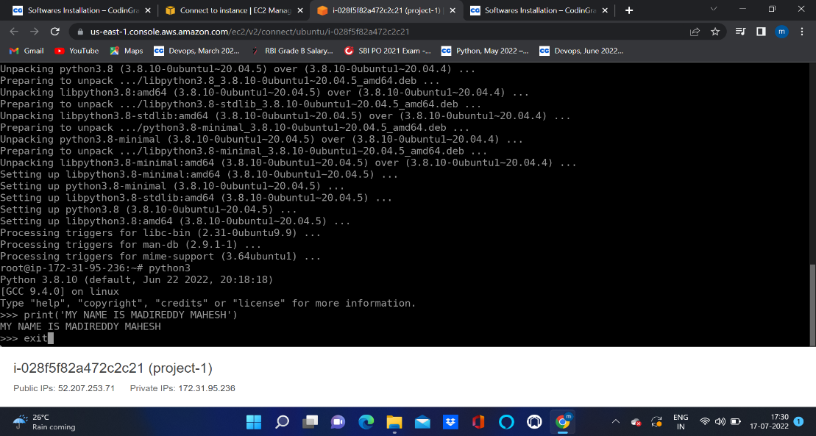

1. To exit from workspace give exit()

* **NODE JS INSTALLATION ON UBUNTU:**

1. **To update the server by using (apt-get update -y) command**
2. **To install nodejs by using (apt install nodejs -y)**
3. **To check the version by using (node -v)**
4. **To run the nodejs by using (nodejs)**

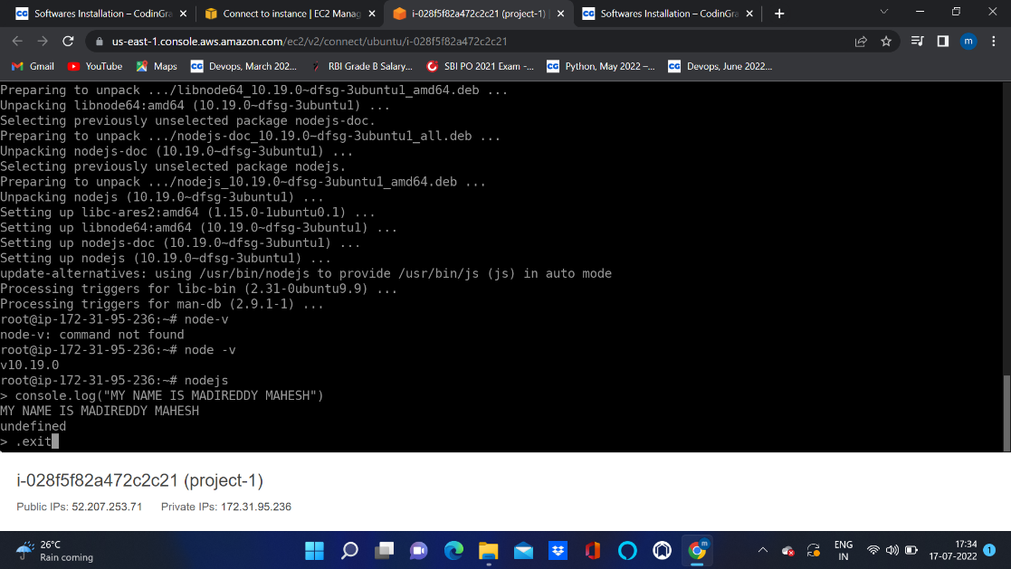

1. To exit from it use .exit

* **ARANGO INSTALLATION ON UBUNTU:**

1. First add the repository key to apt like this
2. wget -q https://download.arangodb.com/arangodb39/DEBIAN/Release.key
3. sudo apt-key add - < Release. Key
4. Use apt-get to install arangodb:
5. By running the (echo 'deb https://download.arangodb.com/arangodb39/DEBIAN/ /' | sudo tee /etc/apt/sources.list.d/arangodb.list) command.
6. Update the package by running the (apt update -y) command.
7. Run the (sudo apt-get install apt-transport-https)
8. By running the (apt-y install arangodb3 ) command.
9. Below pop-up will show after running the (apt -y install arangodb3) command. Here I have set up the password for the root user.
10. It will pop the screen to repeat the password for the root user.
11. Automatically Upgrade Database files.
12. I have restarted the arangodb by running the (systemctl start arangodb3) command.
13. Checked the status of the arangodb. It is actively running.
14. Ran arangosh, below is the pop-up to enter to arango shell

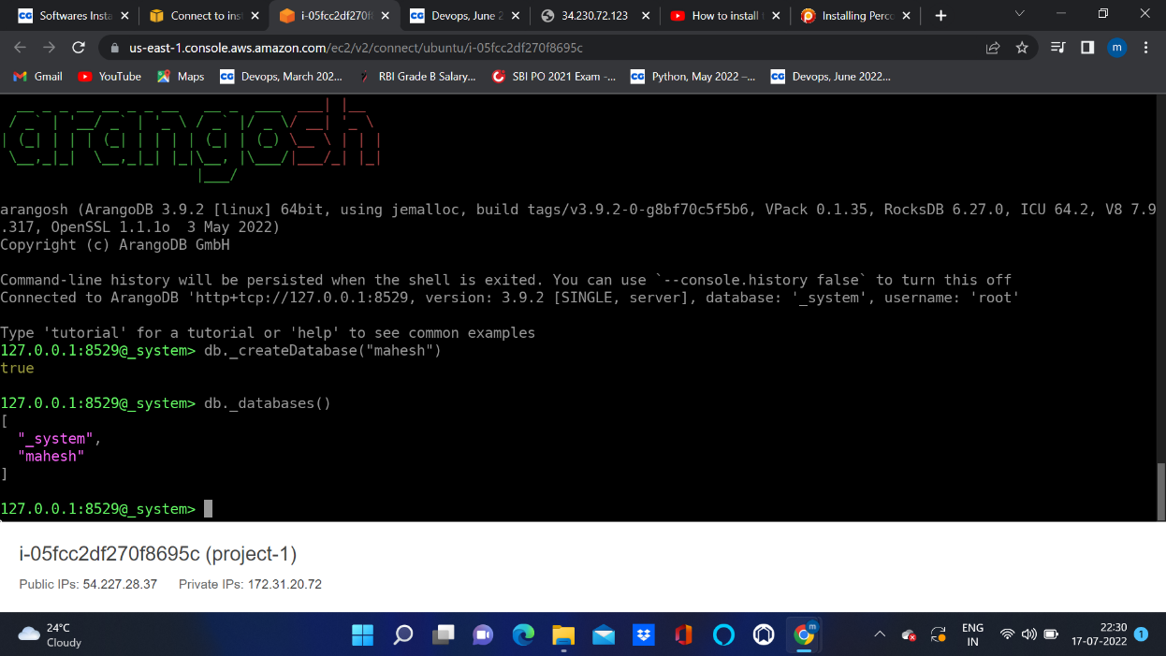

1. Created the New Database by running (db._createDatabase(“mahesh”);
2. Checked how many databases are there in arangodb by running the ( db._databases() ) command.
3. Ran ( vim /etc/arangodb3/arangod.conf ) command, on arangodb configuration file added private address
4. Restarted the arangodb3 by running the ( systemctl restart arangodb3) command.
5. Checked the arangodb3 status by running the ( systemctl status arangodb3) command.
6. Take the public IP address and used port 8529 to launch the arango db and used the root as a username and password which was provided earlier while installing the arango db.

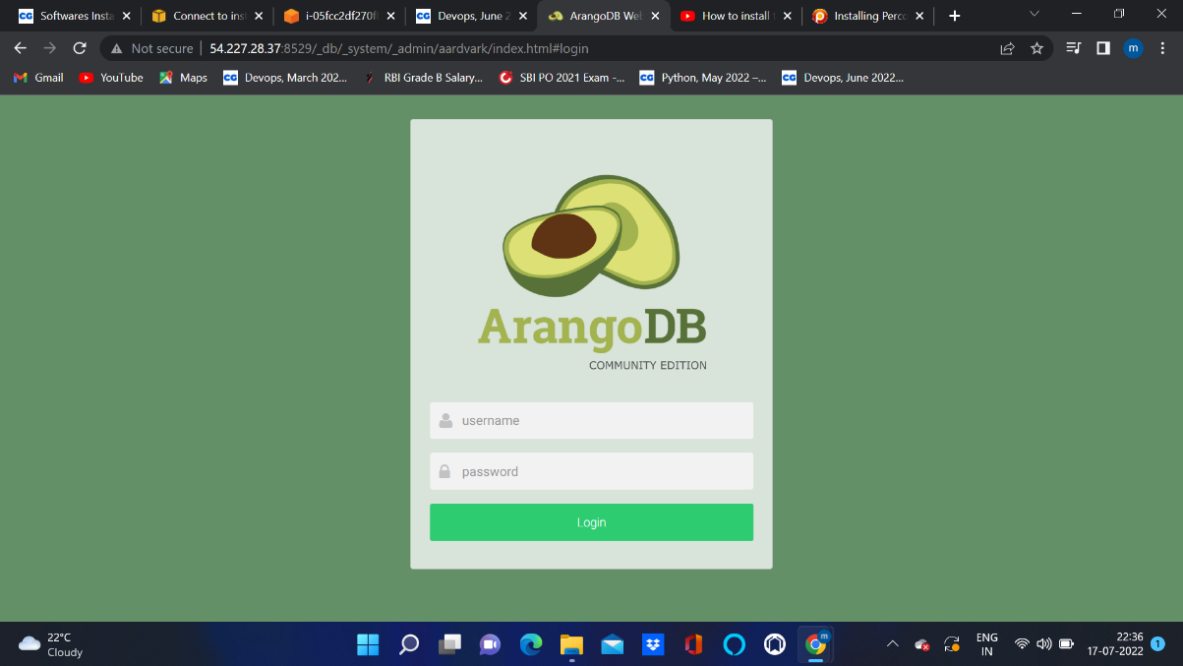

1. After successfully logging into the arangodb it has asked me which database I have to choose.
2. After choosing the System Database on the dashboard below status showing.

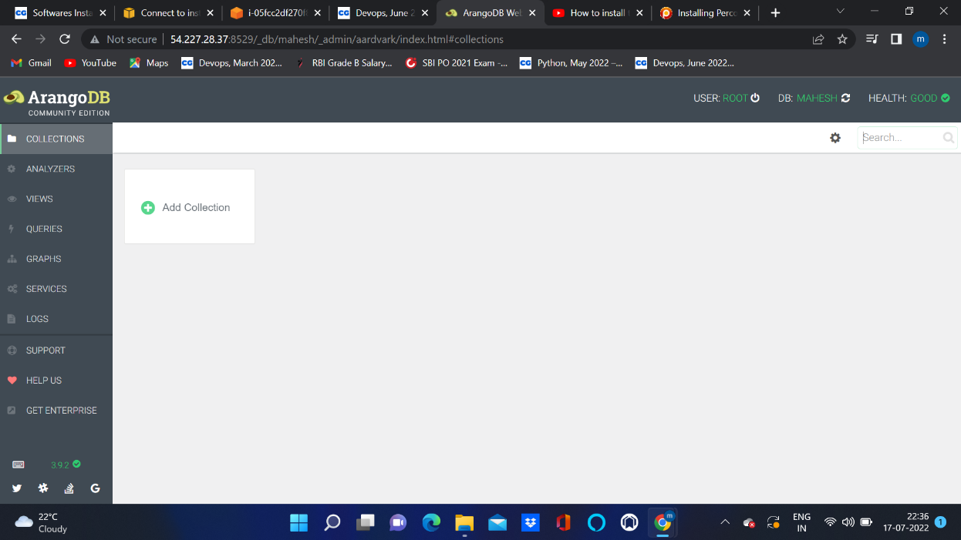

* **PERCONA MYSQL INSTALLATION ON UBUNTU:**

1. Install GnuPG, the GNU Privacy Guard ( apt install gnupg2) command.
2. Fetch the repository packages from Percona web (wget https://repo.percona.com/apt/percona-release_latest.$(lsb_release -sc)_all.deb ) command.
3. Install the downloaded package with dpkg. To do that, I have run the following commands as root ( dpkg -i percona-release_latest.$(lsb_release -sc)_all.deb )
4. Ran percona-release setup ps80 for enabling the percona server 8.0 Repositories.
5. Installed Percona by running ( apt install percona-server-server ) command and the pop-up is shown below to set up the password for the root user.
6. Re-enter the password for the root user.
7. Configuring Percona Server.
8. Setup default authentication plugin as use strong password encryption .
9. Ran mysql -u root –p command to enter into the database shell, it will ask the password which was configured while installing the percona server, we have to enter the password to go percona server.
10. Create Database Mahesh
11. Check how many Data bases are there by using (SHOW DATABASES)

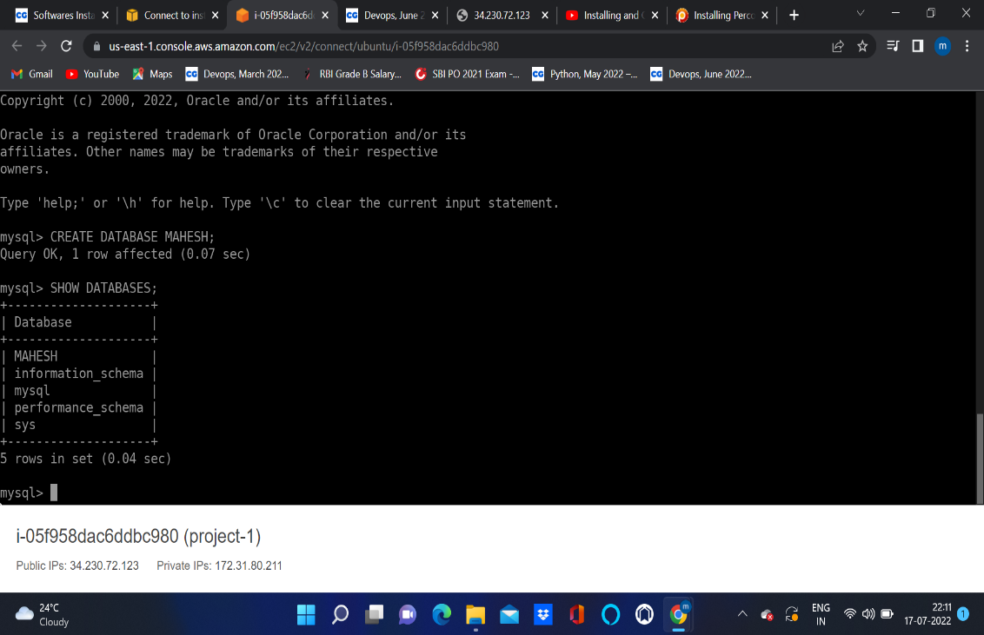

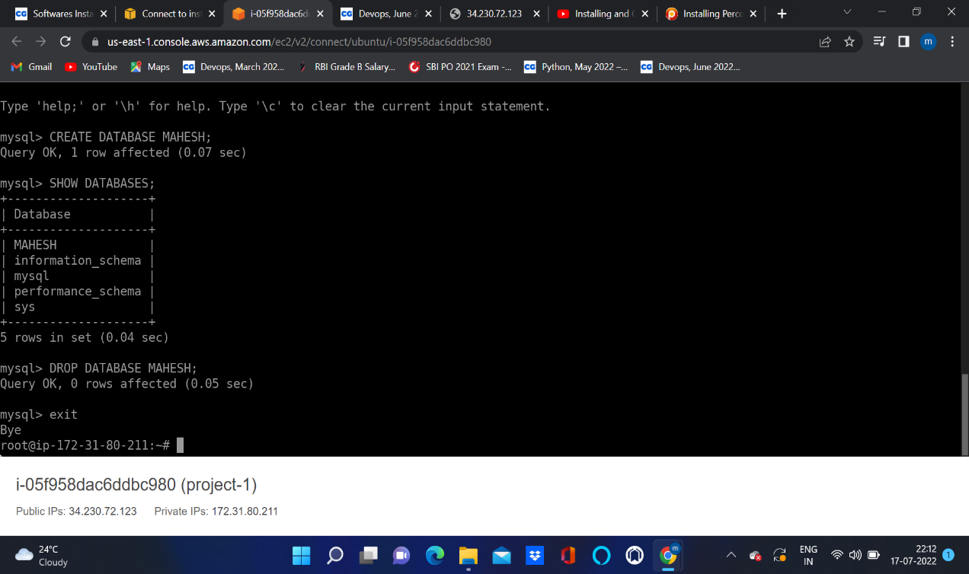

1. Delete DATABASE by using (DROP DATABASE MAHESH)
2. Exit

* **MONGODB INSTALLATION ON UBUNTU:**

1. Mongodb is part of the ubuntu repositories we no longer need to get the resources from the internet.
2. Installed mongodb by running (apt install -y mongodb) command.
3. By running the ( apt update -y ) it will update the mongodb repositories.
4. We start mongodb services by running the ( service mongodb start ) command.
5. Checked mongodb status by running the ( service mongodb status ) command.
6. Upon running the mongo command it will open the mongo shell.
7. Created new database by using ( use Mahesh dB; ) command.
8. To check on which database we are in we can use ( db; ) command.
9. Exit